Final Internship Report

Submitted in partial fulfilment of the internship requirement
Of
Bachelor of Science Artificial Intelligence

Student Name | Humna Imran
Registration No. | 2023-BS-AI-017
Program | BS Artificial Intelligence
Host Organization | Code Savoiur
Internship Duration | 29 June 2026 – 29 August 2026
Industry Supervisor | Ms. Rameesha
University Supervisor | Mr. Arham
Submission Date

Department of Computer Science
The University of Faisalabad

- Introduction
Code Savoiur is the organisation that hosted my internship under its Artificial Intelligence and Machine Learning internship programme (Batch SI-26). The internship was organised as a structured, project-based curriculum rather than a single fixed assignment: interns were given weekly milestones, were expected to maintain their work in version-controlled GitHub repositories, and were guided toward taking a project from an initial idea through to a working, deployed application. This structure meant that the internship was closely aligned with how AI and Machine Learning work is actually carried out in practice, involving not just model building but also data collection, documentation, debugging, and deployment.
During the internship, I worked on two independent projects, both supervised under the same programme. The first involved building a system to automatically identify Roman Urdu and English words within code-switched text, a Natural Language Processing problem. The second, larger project involved building a custom Optical Character Recognition system for Urdu text, an area that combines computer vision with language processing. Both projects are directly relevant to my BS Artificial Intelligence degree, since they required me to apply supervised learning, transformer-based deep learning architectures, honest evaluation methodology, and practical software engineering skills such as version control and deployment. The remainder of this report describes the work carried out on both projects, what I learned from them, and how the experience contributed to my growth as an early-career AI practitioner.
- Tasks and Responsibilities
Across both projects, my responsibilities spanned the full lifecycle of an applied Machine Learning project: understanding the problem, sourcing and preparing data, building and training models, evaluating results honestly (including when they were disappointing), debugging failures, and packaging the finished work into an application that another person could actually use. Table 1 summarises the main technologies and tools I used to do this.
Table 1: Technologies and Tools Used During the Internship
Category | Tools / Technologies Used
Programming language | Python
Deep learning framework | PyTorch, Hugging Face Transformers
Core models | XLM-RoBERTa (token classification), TrOCR / microsoft-trocr-base-printed
Data handling | pandas, NumPy
Computer vision / preprocessing | OpenCV, Pillow
Baseline OCR engine | Tesseract OCR with the Urdu language pack
Visualization | Matplotlib
Development environment | GitHub Codespaces; Google Colab (GPU training)
Version control | Git and GitHub
Model and dataset hosting | Hugging Face Hub
Deployment | Streamlit / Streamlit Community Cloud

Project 1: Roman Urdu-English Code-Switching Language Identification
The first project addressed code-switching: the way many Pakistani social media users mix Roman Urdu and English within the same sentence, and sometimes within the same phrase. Standard NLP tools generally assume a single language per document, so this kind of mixed text is difficult for them to process correctly. My task was to build a model that reads a sentence and classifies each individual word as Urdu (URD), English (ENG), or a mixed or hybrid token (MIX), which makes this a word-level token classification problem rather than a sentence-level one.
Dataset. I built the training data from a public Roman Urdu dataset (the Smat26/Roman-Urdu-Dataset collection of organic Twitter, Facebook, and e-commerce review text, released under a GPL-3.0 licence) rather than starting from scratch. After cleaning and de-duplicating the raw text down to roughly 15,900 usable sentences, I auto-labelled every word using an English wordlist cross-checked against a curated list of common Urdu words that would otherwise be misclassified, then applied a filter to keep only sentences that showed genuine code-switching (a mix of enough Urdu and English words, with English making up a minority of the sentence). This left 220 sentences, which I spot-checked manually before finalising a dataset of 2,490 word-level labels. Figure 1 shows the resulting label balance.
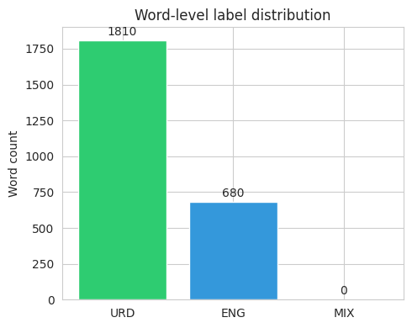
Figure 1: Word-Level Label Distribution in the Code-Switching Dataset
Looking at which words were most frequent within each label also helped me sanity-check the labelling. Figure 2 shows that the most common Urdu-tagged words were everyday grammatical words (hai, ke, ko, mein), while the most common English-tagged words included proper nouns and loanwords, which is consistent with what I would expect from genuinely mixed, informal text.
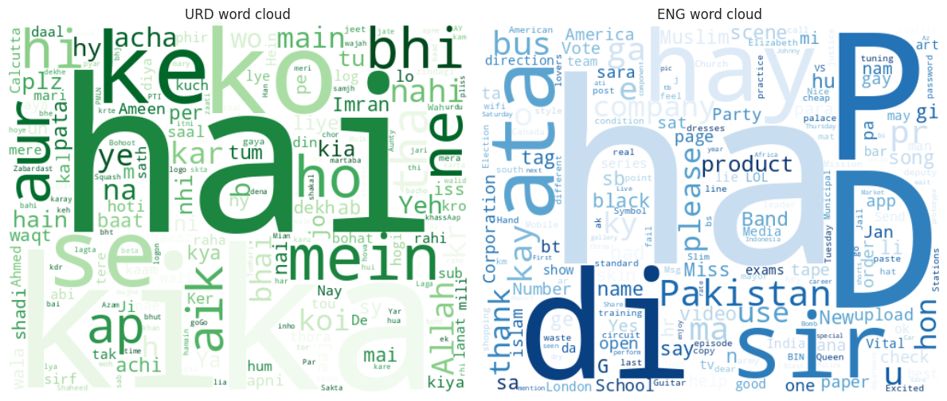
Figure 2: Word Clouds of the Most Frequent Urdu (URD) and English (ENG) Tokens
Model development and training. I fine-tuned xlm-roberta-base, a multilingual transformer model, for token classification across the three labels. Training used an 80/20 split (176 training sentences, 44 held out for testing), 8 epochs, a batch size of 16, and a learning rate of 2e-5, with the Hugging Face Trainer automatically selecting the best checkpoint based on macro F1 score on the evaluation set. Figure 3 shows that training loss dropped steadily while macro F1 rose quickly across the first three epochs before levelling off, which suggested the model had converged given the amount of training data available.
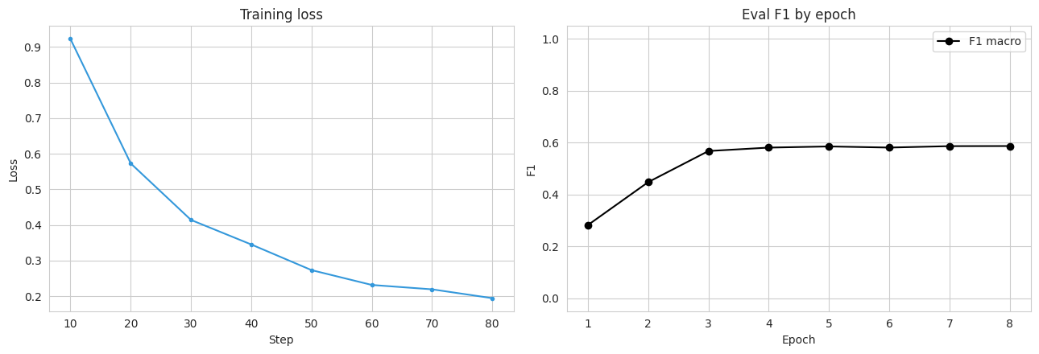
Figure 3: Training Loss and Macro F1 Across Epochs for the Code-Switching Model
Evaluation. On the held-out test set, the model reached 90.75% word-level accuracy. Table 2 breaks this down by label: performance on Urdu and English words was strong, but the model never predicted the MIX label at all.
Table 2: Precision, Recall, and F1-Score by Label for the Code-Switching Model
Label | Precision | Recall | F1-score
URD | 0.933 | 0.942 | 0.937
ENG | 0.836 | 0.812 | 0.824
MIX | 0.000 | 0.000 | 0.000

Figure 4 shows the same result as a confusion matrix: almost all of the model's mistakes involved confusing Urdu and English words with each other (for example, borrowed or ambiguous words), while the MIX row and column are empty.
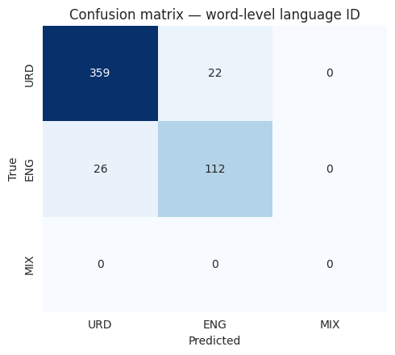
Figure 4: Confusion Matrix for Word-Level Language Identification
Debugging. The fact that MIX never appears was not really a training failure so much as a data problem, and tracing it back was one of the more useful debugging exercises of the internship. My word-level auto-labelling step only accepted tokens matching a strictly alphabetic pattern, which meant that hyphenated hybrid words, the most natural way hybrid Roman Urdu-English words show up in real text, were filtered out of the dataset before they ever had a chance to be labelled MIX. In other words, the model correctly learned that MIX essentially never occurs, because in its training data it never did. I see this as a genuine limitation of the current dataset construction, and I have reported it honestly here rather than leaving it out, since an evaluation section that only reports the flattering numbers would misrepresent what the model can actually do.
Application and deployment. After training, I published the fine-tuned model and the dataset to the Hugging Face Hub, and built a small Streamlit application that loads the model directly from the Hub and lets a user type in a sentence and see each word tagged and colour-coded by predicted language in real time. This gave the project an actual interface rather than leaving it as a notebook result.
Project 2: Urdu Optical Character Recognition (OCR)
The second project was substantially larger in scope: building a custom OCR system for Urdu text. Urdu is normally written in the Nastaliq script, which is highly cursive, flows diagonally rather than sitting on a straight horizontal baseline, and changes each letter's shape depending on its position within a word. Combined with the fact that far less labelled Urdu OCR data exists publicly compared to English, this makes Urdu OCR a genuinely harder problem than English OCR, and it is also a good illustration of why off-the-shelf tools do not always transfer well across languages and scripts.
Data collection. I collected 153 raw Urdu text images across three categories: existing public datasets, my own photographs and screenshots, and computer-generated (synthetic) text images, and built a labels.csv ground-truth file with the correct transcription for each one.
Image preprocessing. My first preprocessing pipeline used a fixed brightness threshold and forced every image into the same fixed size, and it did not work well: on real photographed pages with uneven lighting, the fixed threshold turned shadowed regions into speckled noise, and forcing a uniform size distorted the aspect ratio of images that were naturally very different shapes (single cropped text lines versus full book or newspaper pages). I rebuilt the pipeline to resize each image while preserving its aspect ratio, denoise it gently, and then binarise it using Otsu's method, which recalculates the ideal brightness cutoff for each image individually instead of assuming every photo has the same lighting. Figure 5 compares raw and processed images side by side, and Figure 6 shows why Otsu matters in practice: for one processed page, Otsu automatically chose a threshold of 177, far from the old fixed cutoff of 127, a difference that would have badly misclassified that image's pixels under the original approach.
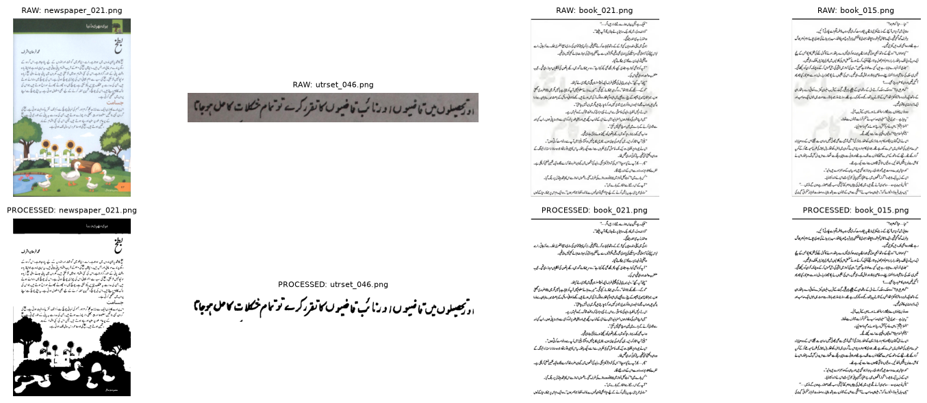
Figure 5: Sample Images Before and After the Preprocessing Pipeline
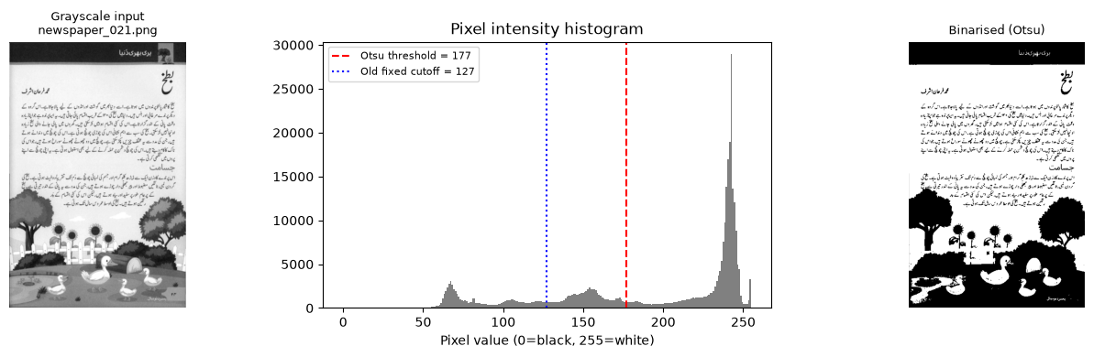
Figure 6: Otsu's Adaptive Threshold Compared with the Original Fixed Cutoff
Baseline evaluation with Tesseract. Before building a custom model, I tested Tesseract, a widely used open-source OCR engine, on five of my processed images using its Urdu language pack, to understand how much a custom model was actually needed. The results were poor: on the two images where I had exact ground truth to compare against, Tesseract recovered only 27% and 0% of the real words respectively (Figure 7), and a closer qualitative look across all five images showed that short, common, or widely spaced words sometimes survived, but dense, multi-ligature Nastaliq text was consistently dropped, truncated, or replaced with characters that were not in the source image at all. This baseline gave me clear, evidence-based justification for why the project needed a custom-trained model rather than an existing OCR tool.
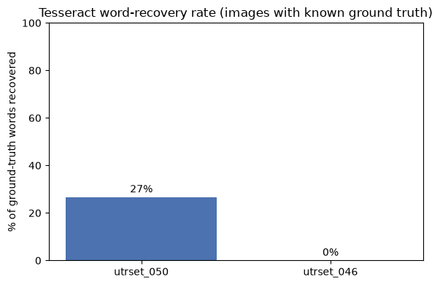
Figure 7: Word-Recovery Rate of Baseline Tesseract OCR on Urdu Text
Dataset expansion. To increase the amount of training data available, I investigated UTRNet's UTRSet-Real and UTRSet-Synth datasets (academic datasets of real and synthetic Urdu text lines, released for research use), and generated 110 additional synthetic Urdu text-line images by rendering short, safe-category news headlines in two different Urdu fonts with right-to-left aware text shaping. This brought the working dataset to 263 labelled image-text pairs.
Model development and training. I fine-tuned microsoft/trocr-base-printed, a transformer-based encoder-decoder OCR model with roughly 334 million parameters, on the 263-image dataset (211 for training, 52 for testing, an 80/20 split). Figure 8 shows this split along with the spread of ground-truth caption lengths, which ranged from short headlines to full transcribed pages of several thousand characters. Training ran for 3 epochs with a batch size of 4 and a learning rate of 5e-5; Figure 9 shows that training loss dropped substantially over the first few batches and then levelled off at around 3.5.
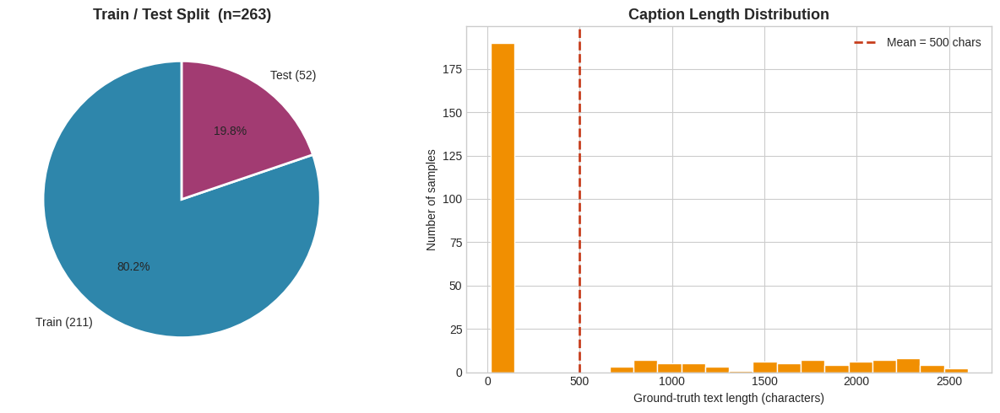
Figure 8: Train/Test Split and Ground-Truth Caption Length Distribution
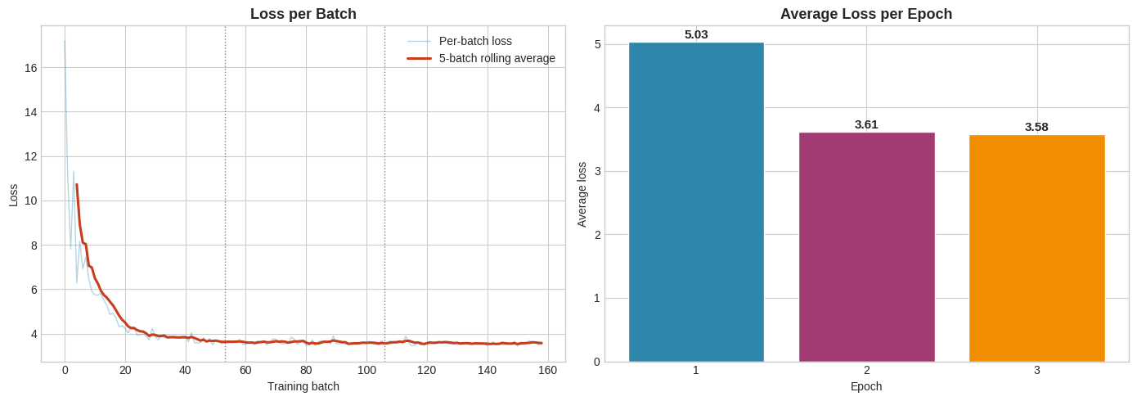
Figure 9: TrOCR Fine-Tuning Loss Across Training
Evaluation and debugging. This is the part of the internship that taught me the most, because the result was not a success story. On the 52 held-out test images, the fine-tuned model reached 0% exact-match accuracy and a mean character-level similarity of only about 0.1%: every single prediction collapsed to the exact same fixed string of placeholder characters, regardless of what the input image actually contained (Figure 10). Figure 11 shows this directly against sample test images and their ground truth. Rather than treat this as simply a failed experiment, I worked through why it happened. The most direct explanation, visible in the training setup itself, is that trocr-base-printed's decoder was pretrained almost entirely on English text, so it starts with very little representation of Urdu script, and 211 training examples across only 3 epochs is a small amount of signal to teach it an entirely new writing system. I also traced part of the problem to a data-loading bug: labels.csv had accumulated two different image-path conventions across earlier weeks of the project, and I had to write a fallback path-resolution step to make sure every image actually loaded during training rather than silently failing. Further documentation on the project also points to a repeated-character degeneration pattern consistent with exposure bias, a known failure mode in sequence generation models, and describes additional training and generation-time adjustments aimed at addressing it; at the time of writing, that follow-up work was still in progress rather than a finished, re-measured result, so I have reported the confirmed evaluation figures above rather than a number I could not directly verify.
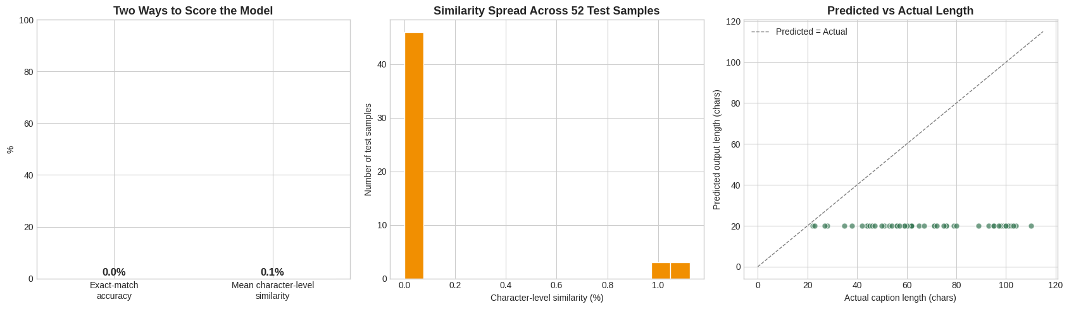
Figure 10: Evaluation of the Fine-Tuned OCR Model on the Held-Out Test Set
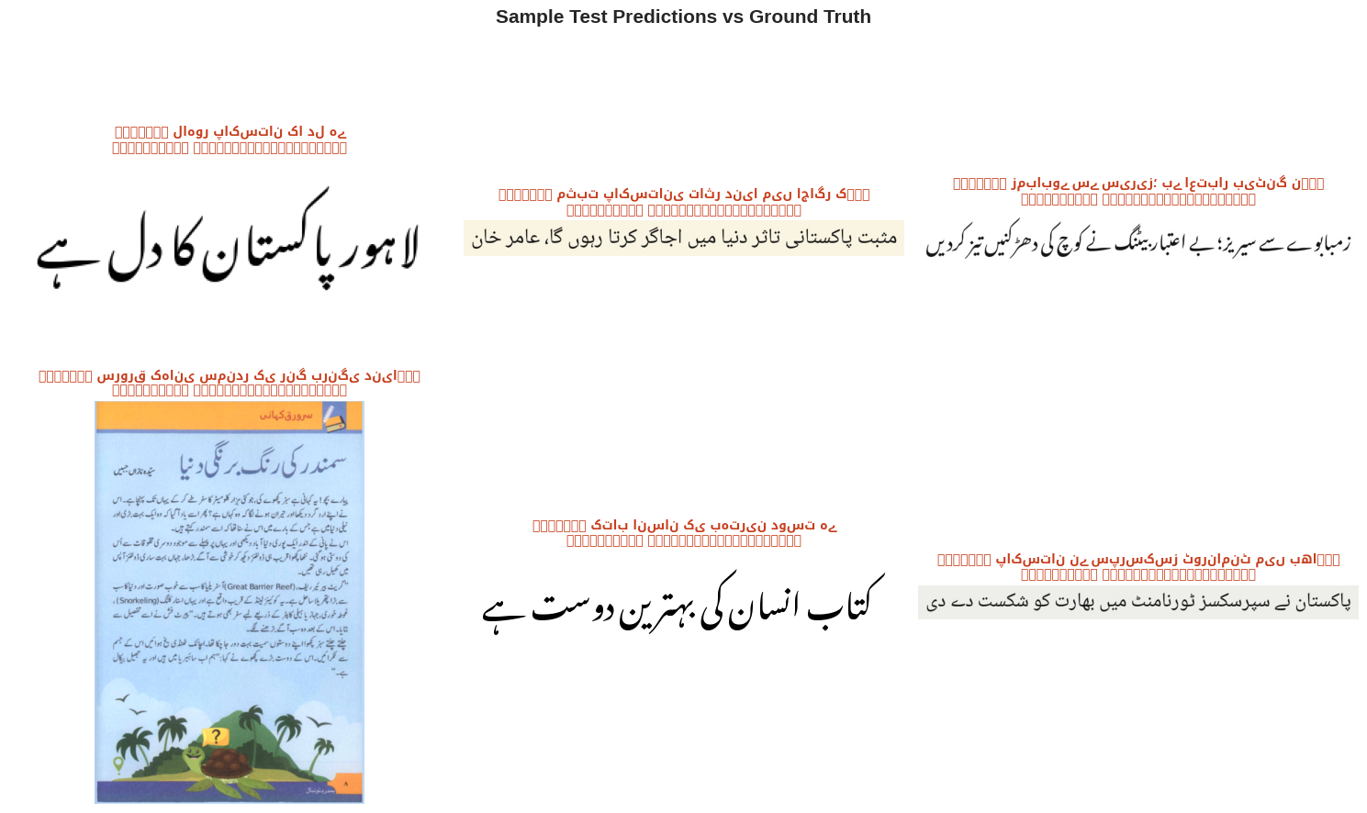
Figure 11: Sample Test Predictions Compared with Ground Truth
Application and deployment. Despite the model's limitations, I still built and deployed a complete application around it: a Streamlit app that accepts an uploaded Urdu image, preprocesses it, runs it through the fine-tuned model pulled live from the Hugging Face Hub, and displays the recognised text. Deploying an imperfect model honestly, rather than only deploying projects that work perfectly, felt like a realistic and valuable part of the experience, since production Machine Learning systems rarely start out working well.
Table 3: Comparison of the Two Internship Projects
Aspect | Project 1: Code-Switching ID | Project 2: Urdu OCR
Task type | Word-level token classification (NLP) | Image-to-text generation (vision + NLP)
Base model | xlm-roberta-base | microsoft/trocr-base-printed
Dataset size | 220 sentences / 2,490 word labels | 263 image-text pairs
Final result | 90.75% word-level accuracy | 0% exact-match (failure diagnosed and documented)
Deployment | Streamlit app + Hugging Face Hub | Streamlit app + Hugging Face Hub

- Learning Outcomes
Working on these two projects gave me practical experience with almost the entire Machine Learning workflow, in a way that lecture-based coursework in my BS Artificial Intelligence degree had only partially prepared me for. Reading about data cleaning, tokenisation, or train/test splitting in a course is different from actually writing the code that filters 15,000 sentences down to a genuinely useful 220, or from discovering that a filtering rule I had written myself had quietly removed an entire label from my own dataset.
On the Natural Language Processing side, I learned how to approach code-switching as a concrete labelling problem, how to fine-tune a multilingual transformer model (xlm-roberta-base) for token classification using the Hugging Face Trainer API, and how to read training curves and confusion matrices critically rather than simply checking whether the overall accuracy number looked acceptable.
On the computer vision and OCR side, I learned why classical image preprocessing choices, such as thresholding method and resize strategy, are not minor implementation details, since they can make the difference between usable and unusable input data. I also gained a much more realistic understanding of what fine-tuning a pretrained model on a script it has barely seen actually requires: it is not simply a matter of running a training loop for a few epochs, and small dataset sizes matter a great deal when a model needs to learn new visual and linguistic patterns essentially from scratch.
Beyond the two specific projects, I also became noticeably more comfortable with the tooling that surrounds real Machine Learning work: structuring a project across GitHub Codespaces and Google Colab, using Git and GitHub properly for version control across many weekly notebooks, publishing models and datasets to the Hugging Face Hub, and turning a notebook-based result into an actual deployed Streamlit application that someone other than me could open and use. These are skills that are easy to underweight in an academic setting, but they were a large part of what made this feel like a real project rather than a classroom exercise.
- Professional Growth and Reflections
The internship pushed me to work far more independently than most of my university coursework does. There was no single instructor checking each step in real time, so when something did not work, such as the OCR model collapsing to a single repeated output, the responsibility for diagnosing it and deciding what to do next was mine. I found this genuinely difficult at times, particularly when I could not immediately tell whether a poor result was a bug in my code, a limitation of the dataset, or a limitation of the underlying model, and I had to develop a habit of checking each of those possibilities systematically rather than guessing.
I also became better at managing a project across multiple weeks rather than in a single sitting. Both projects were structured as a sequence of weekly milestones, and staying organised across notebooks, data folders, and changing file paths (something that directly caused one of the bugs I had to fix in the OCR project) taught me the practical value of consistent naming conventions and clear documentation, not as an abstract best practice but as something I felt the cost of firsthand when I got it wrong.
Perhaps the most important shift for me was in how I think about a disappointing result. Before this internship, I think I would have been tempted to under-report or gloss over a result like the OCR model's 0% exact-match accuracy. Working through it instead, tracing it back to a plausible cause, and writing it up honestly, felt like a more professional and ultimately more useful response than presenting only the parts of the work that succeeded. I do not think this internship turned me into an expert in either Natural Language Processing or Optical Character Recognition, but it did give me a much more realistic sense of what applied AI work actually involves, including the parts that do not go as planned.
- Recommendations
The weekly milestone structure used for both projects worked well for keeping the work paced and manageable, and I would recommend keeping it for future interns. It might help future cohorts, though, to have a short mid-internship checkpoint focused specifically on data pipeline correctness (checking things like label distributions and file path consistency early), since several of the more time-consuming bugs I encountered, in both the code-switching label filter and the OCR file paths, would likely have been caught earlier with a dedicated review step rather than being discovered later during model evaluation.
For the OCR project specifically, given how much harder the problem turned out to be than a three-epoch fine-tuning run could address, it may be worth signalling to future interns earlier that a first attempt at fine-tuning a model on a low-resource script is likely to fail outright, so that time and expectations can be planned around a longer, more iterative training process from the start rather than treating an initial failed run as unexpected.
More generally, I would recommend that future projects in this programme build in a small amount of dedicated time for baseline comparisons, such as the Tesseract baseline I ran before building the custom OCR model, since that step was one of the most useful things I did: it gave me clear, defensible evidence for why the custom model was worth building at all, rather than relying on assumption alone.
- Conclusion
This internship gave me the opportunity to take two Artificial Intelligence projects, one in Natural Language Processing and one in Optical Character Recognition, from an initial idea through data collection, preprocessing, model training, honest evaluation, and finally deployment. The Roman Urdu-English code-switching model reached a solid 90.75% word-level accuracy and is deployed as a working Streamlit application, while the Urdu OCR project, despite a fine-tuned model that did not yet produce usable output, taught me just as much through the process of diagnosing why it failed and documenting that honestly.
Across both projects, I applied and deepened concepts from my BS Artificial Intelligence coursework, including transformer-based model fine-tuning, evaluation methodology, and classical image preprocessing, while also building practical skills in version control, cloud-based model hosting, and application deployment that a purely academic setting does not always provide. Just as importantly, I developed a more realistic, professional attitude toward Machine Learning work, one where an unflattering result is treated as information to investigate rather than something to hide. I expect both the technical skills and this attitude toward honest evaluation to be directly useful in my continued studies and in any future AI-related work I take on.
Appendices
Appendix A: Internship Offer Letter
[A scanned copy of the internship offer letter issued by Code Savoiur is to be inserted here.] (Mandatory)
Appendix B: Internship Completion Certificate
[A scanned copy of the internship completion certificate is to be inserted here.] (Mandatory)
Appendix C: Supporting Documents
[Any additional supporting documents, such as task sheets or correspondence, may be inserted here.] (Optional)
[Photographs from the internship, if available, may also be included in this appendix.] (Optional)

